MANUAL MUTU
(QUALITY MANUAL)
PT. Chitose Internasional Tbk

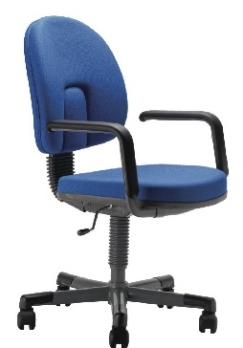

PT. CHITOSE INTERNASIONAL TBK  Jl. Industri III No. 5 Leuwigajah  Cimahi – 40533 - Indonesia | 
Chitose Go Green..

