 |  |  |  |  |  |  |  |  |  | No. | Kode |  | Nama Komponen |  |  |  | Qty | Spesifikasi Komponen
 |  |  |  |  |  |  |  |  |  | 1. | - |  | Manufacture label Electric Type |  |  |  | 1 | HVS Sticker 85 x 55


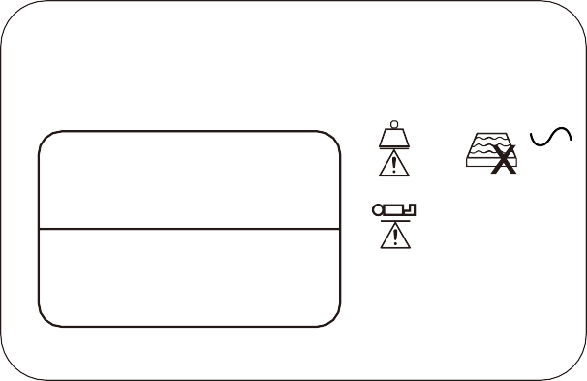

Garis Potong

Note :
- label akan di aplikasikan dengan tinta cap
- Tinta cap tidak mudah luntur
3 |  |  |  |  |  |  | Standard Application : |  |  |  |  | Specification : |  | Finishing : | Unit :  mm | Papper :  A4 |  |  | Scale :  1:1 |     Projection : | Drawing Name :  Manufacture label Electric type
2
1 |  |  |  |  |  |  | Drawn :  Wahyu | Designed/ Customer :  CINT | Checked :  M.Rosyidin |  | Approved :  Donald KL | Status :  PRODUCTION DRAWING |  | Effective Date : | Page :  – | PT. Chitose Internasional Tbk  Research and Development Dept. |  |  |  |  | Product Name :  NSB
NO | DATE | REMARK | DRAWN | CHECKED | APPROVED | APPROVED
85
55
Lot No :
Type :

PT. Chitose Internasional Tbk = 250 Kg
Jln.Industri III No.5 Utama Cimahi I P X 4
40533, Jawa Barat Indonesia
= 185 Kg
Showroom - Marketing Office Distributor Center Jln. H.M.S. Mintaredja Baros Cimahi 40521, Indonesia Ph. +62 22 206 4777
AC 230V~,50/60Hz
Duty cycle 2 min ON/18 min OFF
Manufactured by Chitose Int. : 10%, Max 2 min/ 18 min.
Daya : 345 VA

 |  |  |  |  |  |  |  |  |  | No. | Kode |  | Nama Komponen |  |  |  | Qty | Spesifikasi Komponen
 |  |  |  |  |  |  |  |  |  | 1. | - |  | Manufacture label Crank Manual Type |  |  |  | 1 | HVS Sticker 85 x 55




Garis Potong

Note :
- label akan di aplikasikan dengan tinta cap
- Tinta cap tidak mudah luntur
3 |  |  |  |  |  |  | Standard Application : |  |  |  |  | Specification : |  | Finishing : | Unit :  mm | Papper :  A4 |  |  | Scale :  1:1 | Projection : | Drawing Name :  Manufacture label Crank Manual type
2
1 |  |  |  |  |  |  | Drawn :  Wahyu | Designed/ Customer :  CINT | Checked :  M.Rosyidin |  | Approved :  Donald KL | Status :  PRODUCTION DRAWING |  | Effective Date : | Page :  – | PT. Chitose Internasional Tbk  Research and Development Dept. |  |  |  |  | Product Name :  NSB
NO | DATE | REMARK | DRAWN | CHECKED | APPROVED | APPROVED
85

Lot No :
Type :

PT. Chitose Internasional Tbk
Jln.Industri III No.5 Utama Cimahi = 245 Kg
40533, Jawa Barat Indonesia

Showroom - Marketing Office = 175 Kg
Distributor Center Jln. H.M.S. Mintaredja Baros Cimahi 40521, Indonesia Ph. +62 22 206 4777

Manufactured by Chitose
55

