NO | NAMA BAHAN BAKU |  | NAMA SUPPLIER | SATUAN
1 | 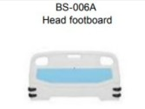 | BS 006A HEAD FOOTBOARD | BOSSAY MEDICAL APPLIANCE Co, Ltd. | SET
2 | 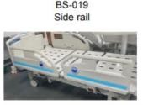 | BS-019 SIDE RAIL | BOSSAY MEDICAL APPLIANCE Co, Ltd. | SET
3 | 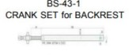 | BS-43-1 CRANK SET FOR BACKREST | BOSSAY MEDICAL APPLIANCE Co, Ltd. | PCS
4 | 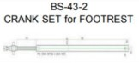 | BS-43-2 CRANK SET FOR FOOTREST | BOSSAY MEDICAL APPLIANCE Co, Ltd. | PCS
5 | 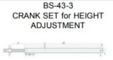 | BS-43-3 CRANK SET FOR ADJUSTMENT | BOSSAY MEDICAL APPLIANCE Co, Ltd. | PCS
6 | 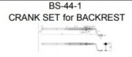 | BS-44-1 CRANK SET FOR BACKREST | BOSSAY MEDICAL APPLIANCE Co, Ltd. | PCS
7 | 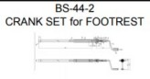 | BS-44-2 CRANK SET FOR FOOTREST | BOSSAY MEDICAL APPLIANCE Co, Ltd. | PCS
8 | 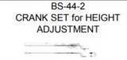 | BS-44-2 CRANK SET FOR ADJUSTMENT | BOSSAY MEDICAL APPLIANCE Co, Ltd. | PCS
9 | 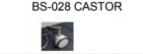 | 5 INCH WITH LOCK M16 X  25MM | BOSSAY MEDICAL APPLIANCE Co, Ltd. | SET
10 | 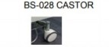 | 5 INCH WITHOUT LOCK M16 X 25MM | BOSSAY MEDICAL APPLIANCE Co, Ltd. | SET
11 | 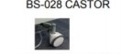 | 5INCH CENTRAL LOCK | BOSSAY MEDICAL APPLIANCE Co, Ltd. | SET
12 | 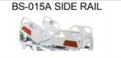 | SIDERAIL WOTHOUT CONTROL PANEL 4PCS/SET | BOSSAY MEDICAL APPLIANCE Co, Ltd. | SET

NO | NAMA BAHAN BAKU |  | NAMA SUPPLIER | SATUAN
13 | 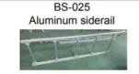 | ALLUMUNIUM ALLOY INSTALLATION WHOLE IN THE TOP TUBE 2PCS PER SET | BOSSAY MEDICAL APPLIANCE Co, Ltd. | SET

