MAINTENANCE TRAINING MATERIAL FOR BED TYPE CB 7003 D
Table 1. Crank Assy Replacement Method and Work Sequence * Hi-Lo Case
No | Working Order | Method
1 | Raise the Bed to the highest level | - Raise the Bed to the highest level  - Turn the Crank Handle to the right and stop where the upstroke becomes heavier.
2 | Remove both springs | Remove both Springs using the Hook JIG
3 | Lower the Bed to the Lowest level | Turn the Crank Handle to the left and stop where the stoper meets
4 | Remove the Comple Crank Rod End | Release the Snap pin and pull the pin
5 | Remove the Crank Assy | - Open the Instruction Label on the handle and open the screw, then remove the handle.
5 | Remove the Crank Assy | - Remove the two M10 bolts attached to the cross member.
5 | Remove the Crank Assy | - Remove the Crank Assy
6 | Installation of Crank Assy | - Install the handle to the cross frame foot side hole and tigh the screw securely
6 | Installation of Crank Assy | - Install the two M10 bolts and tighten
6 | Installation of Crank Assy | - Install the end of the rod axis on the torque tube bracket using the pin, collar and snap pin.
7 | Raise the Bed to the highest level | Turn the Crank Handle to the right and stop where the upstroke becomes heavier.
8 | Install both Springs | Install the two springs using the hook JIG
9 | Lower the Bed to the Lowest level | Turn the Crank Handle to the left and stop where the stoper meets
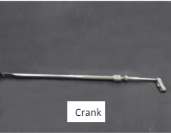
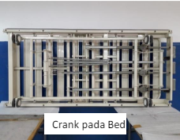

MAINTENANCE TRAINING MATERIAL FOR BED TYPE CB 7003 D
Table 1. Caster Replacement Method and Work Sequence
No | Urutan Kerja | Metoda/Cara Kerja
1 | Prepare everything related to replacement work | Raise the bed by turning the crank handle clockwise until there is enough space (between the floor and casters), then install the stand.
2 | Remove the Casters | Loosen the Nut with a 21 mm wrench and remove the caster
3 | Install Casters | Insert the caster thread into the foot pipe thread and tighten using a wrench until tigh
4 | Make sure the installation is correct | Make sure the 16 diameter Spring Washer is even and has no gaps
5 | Take out the chockstand | Turn the crank handle clockwise once there is space then pull the support holder out.
6 | Make sure all functions are operational | Make sure the forward and backward rotation is horizontal without any abnormalities.  Make sure there are no abnormalities in the lock function.
