MAINTENANCE TRAINING MATERIAL FOR BED TYPE CB 7011 D
Table 1. Crank Assy Replacement Method and Work Order * Hi-Lo Case
No | Work Order | Method
1 | Raise the bed to the highest level | Turn the crank handle to the right and stop where the upstroke become heavier
2 | Remove both Springs | Remove both Springs using the Hook JIG
3 | Lower the Bed to the Lowest level | Turn the Crank Handle to the left and stop where the stoper meets
4 | Remove the Comple Crank Rod End | Release the Snap pin and pull the Pin
5 | Remove the Crank ASSY | 1. Open the Instruction Label on the handle and unscrew the screw, then remove the handle.
5 | Remove the Crank ASSY | 2. Remove the two M10 bolts attached to the cross member
5 | Remove the Crank ASSY | 3. Remove the Crank Assy
6 | Installation of CRANK ASSY | 1. Install the handle to the cross frame foot side hole and tigh the screw securely.
6 | Installation of CRANK ASSY | 2. Install the two M10 bolts and tighten
6 | Installation of CRANK ASSY | 3. Install the end of the rod axis on the BRKT torque tube using the pin, collar and snap pin.
7 | Raise the Bed to the highest level | Turn the Crank Handle to the right and stop where the upstroke becomes heavier.
8 | Install both Springs | Install the two springs using the hook JIG
9 | Lower the Bed to the Lowest level | Turn the Crank Handle to the left and stop where the stoper meets

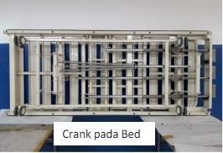
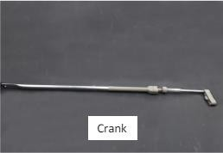

MAINTENANCE TRAINING MATERIAL FOR BED TYPE CB 7011 D
Table 2. Method and Sequence of Cylinder Replacement Process
No | Work Order | Method
Cylinder Removal Process
1 | Raise the Bed to the highest level | Turn the Crank Handle clockwise and stop where the force /rotation of the crank be comes heavier
2 | Install the Jig (round iron diameter 10 x 8cm) | Insert the Jig between BRKT1 and Cross Frame BRKT while pulling the operating lever
3 | Disconnect Control Cable | Loosen the M5 Nut using a 10 Ring Wrench and remove the Jig.
3 | Disconnect Control Cable | Loosen the screw with the H+ screwdriver until the cable stopper is loose
4 | Remove the front cylinder from Bottom A | Remove the Snap Pin with pliers and pull the pin out and hang on the BRKT.
5 | Remove the rear cylinder from the BRKT Cross Frame | Remove the Snap Pin with pliers and pull the pin, so that the Cylinder Comple comes off.
6 | Remove the Cylinder from BRKT2, Cylinder cover and Nut. | Turn the Cylinder counterclockwise, first BRKT2
New Cylinder Installation Process
7 | Install Nut M10 and Cylinder Cover and BRKT2 to Cylinder | Install the Nut, Cylinder Cover and BRKT2 into the Cylinder by inserting and turning it clockwise
8 | Install the Cylinder set to the BRKT Cross Frame | 1. Insert the BRKT2 part into the Cross Frame BRKT after the holes are aligned
8 | Install the Cylinder set to the BRKT Cross Frame | 2. Insert the end of the Cylinder into Bottom A BRKT , if the holes are aligned, insert the pin and install the snap pin.
9 | Install the end of the Control Cable | Attach the end of the Control Cable by inserting it through the cable holder and bolt hole on BRKT1.
10 | Install the Jig | Insert the Jig between BRKT1 and Cross Frame BRKT by pressing Bottom A.

11 | Control Cable Settings | The wire on the Control Cable is pulled with pliers and the Nut is tightened with a 10 ring wrench, after that the screw is also tightened with a screwdriver.
13 | Operation function check | Operate the lever to ensure that you can raise and lower the bottom without Anomaly."

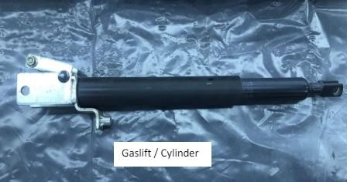
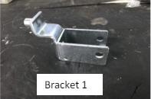
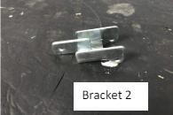

MAINTENANCE TRAINING MATERIAL FOR BED TYPE CB 7011 D
Table 3. Control Cable Replacement Methods and Work Order
No | Work Order | Method
Process of Removing Control Cable
1 | Raise the Bed to the highest level | Turn the Crank Handle clockwise and stop where the force/ rotation of the crank becomes heavier.
2 | Install the Jig (round iron diameter 10x8cm) | Insert the Jig between BRKT1 and Cross Frame BRKT while pulling the operating lever
3 | Disconnect Control Cable | 1. Loosen the M5 Nut using a 10 ring wrench and remove the Jig.
3 | Disconnect Control Cable | 2. Loosen the screw with the H+ screwdriver until the stopper cable is loose.

 |  | 3. Open the clamping plate (2 screws) with the plus driver.
 |  | 4. Open gap between the Cable Holder Plate and Hook with a min screw driver and remove the Control Cable from the hook.
The Process of Installing a New Control Cable
4 | Install the New Control Cable | 1. Install the pendulum on the Hook, insert it into the cable stopper plate
4 | Install the New Control Cable | 2. Install the clamp and insert the new Control Cable then tighten the screw.
4 | Install the New Control Cable | 3. Install the JIG between BRKT1 and Cross Frame BRKT by pressing Bottom A
5 | Setting Control Cable | The wire on the Control Cable is pulled using pliers and tightened the Nut using 10 wrench.
6 | Check operation function | Operate the lever to ensure that you can raise and lower the bottom without any anomalies.
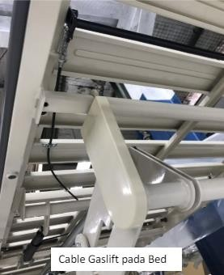
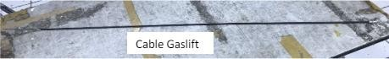

MAINTENANCE TRAINING MATERIAL FOR BED TYPE CB 7011 D
Table 4. Caster Replacement Methods and Work Order
No | Work Order | Method
1 | Prepare everything related to replacement work | Raise the bed by turning the crank handle clockwise until there is enough space (between the floor and the casters), then install the chockstand.
2 | Remove the Casters | Loosen the Nut with a 21 mm wrench and remove the casters.
3 | Install Casters | Insert the caster thread into the foot pipe thread and tighten using 21 mm wrench until tigh.
4 | Make sure the installation is correct | Make sure the 16 diameter Spring Washer is even, there are no gaps.
5 | Take out the Chockstand | Turn the crank handle clockwise once there is space then pull the support holder out.
6 | Make sure the operation function | Make sure the forward and backward rotation is horizontal without any abnormalities.  Make sure there are no abnormalities in the lock function.
